Sprint 1 - Endurance Design Document

October 30, 2023

Table of Contents

1. Executive Summary 3

1.1 Project Overview 3

1.2 Purpose and Scope of this Specification 3

2. Product/Service Description 3

2.1 Product Context 3

2.2 User Characteristics 3

2.3 Assumptions 3

2.4 Constraints 3

2.5 Dependencies 3

3. Requirements 4

3.1 Functional Requirements 4

3.2 Security 4

3.2.1 Protection 4

3.2.2 Authorization and Authentication 4

3.3 Portability 4

4. Requirements Confirmation/Stakeholder sign-off 4

5. System Design 5

5.1 Algorithm 5

5.2 System Flow 5

5.3 Software 6

5.4 Hardware 6

5.5 Test Plan 7

5.6 Task List/Gantt Chart 8

5.7 Staffing Plan 8

# Executive Summary

## Project Overview

The current project is to test the endurance of a Sphero Bolt Robot when circumnavigating a track. Using specific software for the robot and block code, the goal is to program the robot to successfully and accurately roll across a rectangular track without colliding into other objects.

## Purpose and Scope of this Specification

The purpose of this specification is to have University Students program a robot to perform several different sprints accurately and efficiently.

In Scope

This document addresses requirements related to Sprint 1 of The Robot Project:

* Program the robot to successfully circumnavigate a rectangular track in room HH 208.

Out of Scope

The following items of The Robot Project are out of scope:

* Sprint 2: Program the robot to accurately run a figure 8 course 5 times.
* Sprint 3: Program the robot to run an obstacle course.

# Product/Service Description

## Product Context

This Sphero Bolt Robot is part of an entire line of other robots, such as the Sphero Sprk and Sphero Sprk+. The Sphero Bolt Robot used for this project can be controlled through block code via the Sphero Edu software. The robot has the ability to roll to specific locations at certain speeds and directions, as well as turn specific colors and speak.

## User Characteristics

* University Student
* First Year CS/SE Major
* Entry Level Programming Knowledge

## Assumptions

* Assumes the Sphero Edu software is already installed on device.
* Assumes that robot is calibrated to face the initial direction it will move in before starting program.

## Constraints

* Size of the classroom HH 208.
* Limited availability of HH 208.

## Dependencies

* Requires up to date version of Sphero EDU software.

# 

# Requirements

## Functional Requirements

| Req# | Requirement | Comments | Priority | Date Rvwd | SME Reviewed / Approved |
| --- | --- | --- | --- | --- | --- |
| ENDUR_01 | Circumnavigation | System must allow the robot to efficiently circumnavigate the periphery of HH208. Robot will utilize degree inputs within the roll command to accurately follow the outlined path in HH208. | Priority 1 | 10/26/23 | Chris, Marwan, Mike |
| ENDUR_02 | LED Capability | The system allows the robot to output LED color using the main LED command and RGB value inputs. | Priority 1 | 10/26/23 | Chris, Marwan, Mike |
| ENDUR_03 | Sound Support | The system allows the robot to output audio cues using the speak, and command. | Priority 1 | 10/26/23 | Chris, Marwan, Mike |
| ENDUR_04 | Turning | Robot will use inputs with the roll command to turn at the center of yellow tiles. | Priority 2 | 10/26/23 | Chris, Marwan, Mike |
| ENDUR_05 | Preventing Collision | Robot will avoid colliding with objects in HH208 using inputs from the roll command. | Priority 2 | 10/26/23 | Chris, Marwan, Mike |

## Security

### Protection

* The main factor that protects the system from accidental access is Bluetooth connection to a specific device. A Bluetooth connection must be made to the robot to connect to it, and only one user can connect at a time.

### Authorization and Authentication

* To authorize robot use, the user must know robot name to authenticate it through the Sphero Edu Software.

## Portability

* High environmental independence
* Compatible with iOS, Android, Windows, and MacOS.

# Requirements Confirmation/Stakeholder sign-off

|  |  |  |
| --- | --- | --- |
| Meeting Date | Attendees (name and role) | Comments |
| 10/26/23 | Chris D., Marwan E., Mike M. | Confirmed all requirements. |

# System Design

## Algorithm

* Start
* Step 1: Set Main LED to (0,255,0).
* Step 2: Speak “Ready, set, go!” and wait.
* Step 3: Roll 0 degrees at 100 speed for 9.6 seconds.
* Step 4: Delay for 1 second.
* Step 5: Roll 90 degrees at 100 speed for 5 seconds.
* Step 6: Delay for 1 second.
* Step 7: Roll 180 degrees at 100 speed for 9.6 seconds.
* Step 8: Delay for 1 second.
* Step 9: Roll 270 degrees at 100 speed for 5 seconds.
* Step 10: Delay for 1 second.
* Step 11: Set Main LED to (255,0,0).
* Step 12: Speak “I’m done and I need water.”
* Step 13: Stop
* Done.

## System Flow

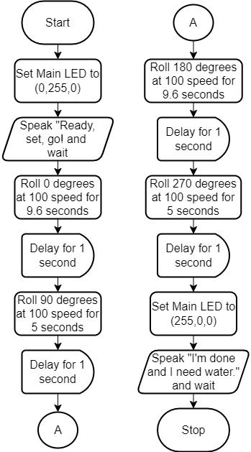

## Software

The software used for this project was block code in the Sphero Edu application.

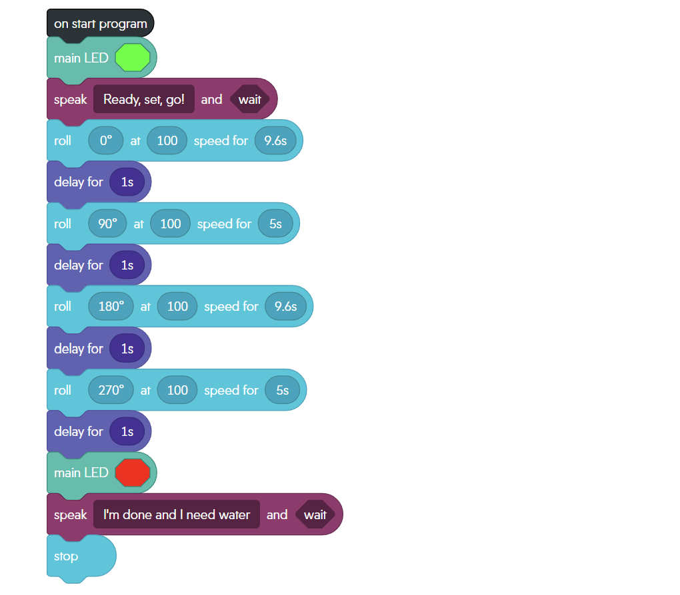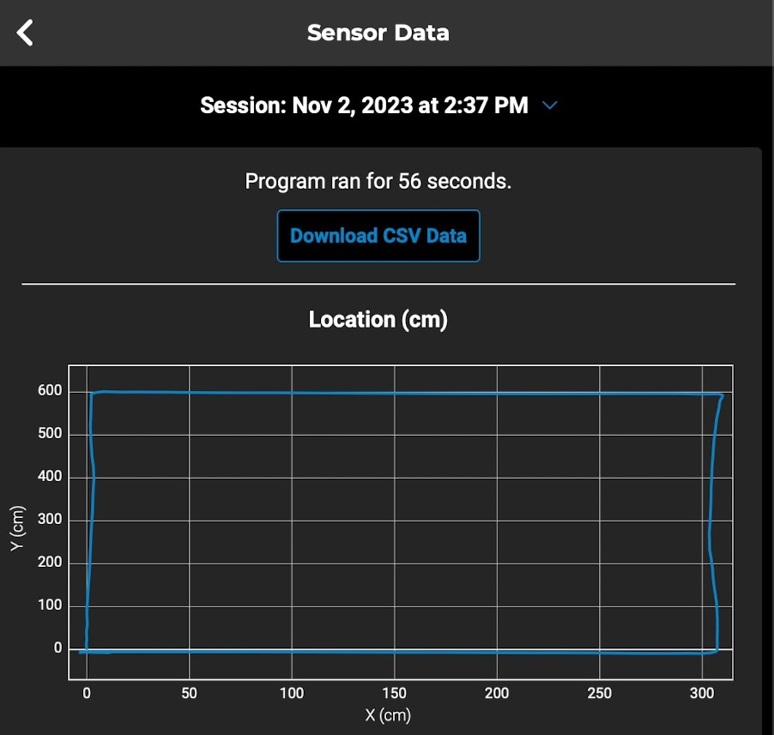

## Hardware

Hardware platforms used:

* Apple MacBook Air
* Apple iPhone
* Sphero Bolt.

## Test Plan

| **Reason for Test Case** | **Test Date** | **Expected Output** | **Observed Output** | **Staff Name** | **Pass/Fail** |
| --- | --- | --- | --- | --- | --- |
| Test if Main LED is successfully lighting up green. | 11/02/23 | Main LED will glow green when program starts. | Robot main LED glowed green. | Chris, Marwan, Mike | Pass |
| Test if Robot Speaks “Ready Set Go” | 11/02/23 | Robot Speaks “Ready, Set, Go!” in the beginning of the program | Robot spoke “Ready, Set, Go!” | Chris, Marwan, Mike | Pass |
| Test if Robot completely rolls to the first corner of the track. | 11/02/23 | Robot rolls to the first corner. | Robot stopped short before reaching the first corner of track. | Chris, Marwan, Mike | Fail |
| Test if Robot completely rolls to the first corner of the track. | 11/02/23 | Robot rolls to the first corner. | Robot successfully reached the first corner of the track. | Chris, Marwan, Mike | Pass |
| Test if Robot completely rolls to the second corner | 11/02/23 | Robot rolls to the second corner. | Robot successfully reached the second corner of the track. | Chris, Marwan, Mike | Pass |
| Test if Robot completely rolls to the third corner | 11/02/23 | Robot rolls to the third corner. | Robot successfully reached the third corner of the track. | Chris, Marwan, Mike | Pass |
| Test if Robot completely rolls to its original position | 11/02/23 | Robot rolls to the starting corner. | Robot successfully reached the corner it started at. | Chris, Marwan, Mike | Pass |
| Test if Main LED is successfully lighting up red. | 11/02/23 | Main LED will glow red when the robot reaches its starting position. | Robot main LED glowed red once it reached its original position. | Chris, Marwan, Mike | Pass |
| Test if Robot Speaks “I’m done and I need water.” | 11/02/23 | Robot Speaks “I’m done and I need water” at the end of the program | Robot spoke “I’m done and I need water.” | Chris, Marwan, Mike | Pass |

## Task List/Gantt Chart

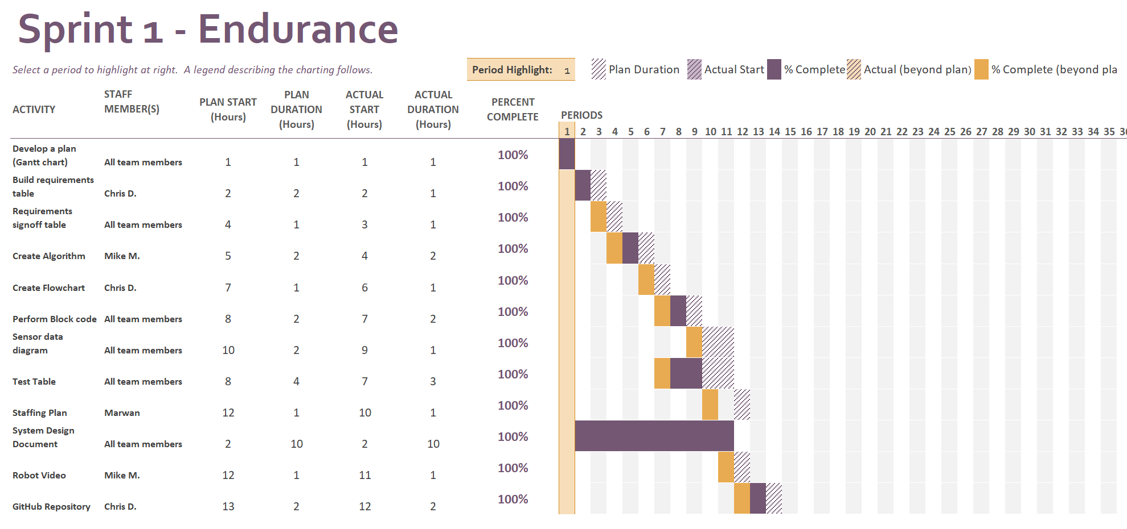

## Staffing Plan

| Name | Role | Responsibility | Reports To |
| --- | --- | --- | --- |
| Chris DeTullio | Group Member | GitHub Repository Owner, Flowchart, Requirements Table | Mike and Marwan |
| Marwan Elgoghel | Group Member | Staffing Plan, Test Table | Chris and Mike |
| Mike Montulet | Group Member | Algorithm, Robot Video | Chris and Marwan |